|  |  |  |
| --- | --- | --- |
| **Canon EOS 850D (Body Only)**  Máy ảnh Canon EOS 850D (Body Only)  canon eos 850d body 4canon eos 850d body 3 canon eos 850d body 1 Canon EOS 5D Mark IV 1 |  | **Featured information:**  5-axis Digital anti-vibration, stable  24.1MP APS-C CMOS Sensor/Digic 8 Processor  Wifi and Bluetooth connection  4K UHD video recording at 25fps  Price : $ 800  **Specifications:**  Image Proportions  3:2  Sensor Type  CMOS  Image Format  JPEG, RAW, C-RAW, RAW+JPEG, C-RAW+JPEG  Anti-Vibration  Digital, 5-Axis (Movie only)  Lens Mount  EF/EF-S  Sensor Format  APS-C  Resolution  24.1 Megapixels  Size photo  6000 x 4000 |

**Overview:**

Canon EOS 850D is equipped with advanced features suitable for high-quality cameras. This is the perfect model for professional photographers. Accordingly, this DSLR camera combines a 24.1MP APS-C CMOS sensor with professional 4K recording mode. There are a total of 45 focus points on the viewfinder, and the live view screen uses Dual Pixel CMOS AF. In addition, the camera also has Wifi connectivity and a user-friendly interface.

With valuable moments sometimes appearing only briefly, this poses a challenge to the fast recording ability of high-quality cameras. Accordingly, the Canon EOS 850D camera will help you not miss any moment in front of your eyes with continuous shooting mode at 7.5 frames per second in Live view One-Shot AF or up to 7 frames per second. in viewfinder mode.



Canon EOS 850D uses a built-in Wifi connection to quickly share and backup your images and videos. With the Canon Camera Connection application available on both iOS and Android, it will help you connect wirelessly to the camera easily, conveniently handling remote operations such as adjusting Remote Shooting mode. Transfer files via smartphone or back up on cloud data. Transfer photos simultaneously during shooting. And remotely play back images and videos on your smart device.

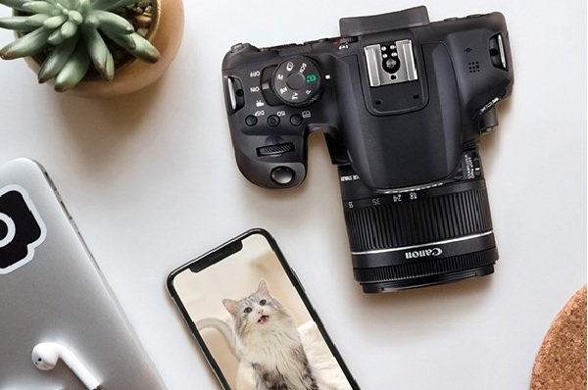

You can take photos with the touchscreen at multiple angles including low angles above the ground. Besides, the LCD screen on the EOS 850D can let you view and adjust the focus. AF-ON button is added for you to enjoy more convenience in shooting.

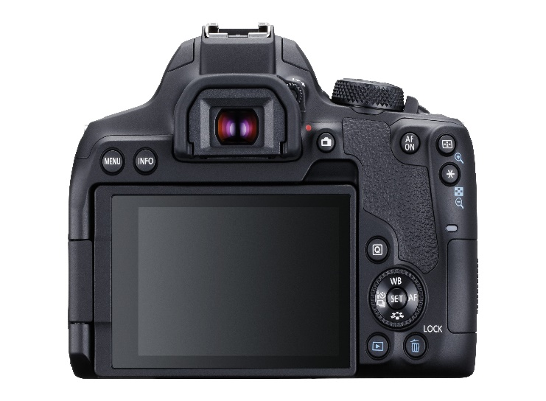

Scene Intelligent Auto is a fully automatic mode. When using this mode, it allows the camera to analyze the scene and automatically make optimal settings. Auto mode also adjusts focus by detecting whether the subject is stationary or moving